Predicting Pavement Condition Index Using a Novel Image Regression Model

Tianjie Zhang¹, Hao Wang², Yang Lu*
¹ Center for Advanced Infrastructure and Transportation, Rutgers, The State University of New Jersey, New Brunswick, NJ, 08854, USA
² Department of Civil and Environmental Engineering, Rutgers, The State University of New Jersey, New Brunswick, NJ, 08854, USA
* Corresponding author, Department of Civil Engineering, Boise State University, Boise, ID, 83725, USA Email: yanglufrank@boisestate.edu

ABSTRACT
Efficient and accurate evaluation of the Pavement Condition Index (PCI) is significant for the Pavement Management System (PMS). However, traditional visual inspection methods are labor-intensive and may delay the traffic flow. Although image classification, distress targeting and image segmentation have been popularly utilized in pavement engineering, using these methods to calculate PCI is not systematic. Thus, the objective of this work is to develop a methodology for predicting PCI directly from top-down view images. A novel Pavement Condition Index Neural Network (PCINet), a convolutional neural network-based method, is proposed in this work. Compared to the traditional image classification and segmentation methods, PCINet is an image regression method that integrates image pattern recognition into practical engineering index prediction, by taking images as input, learning the hidden patterns of images and linking them to PCI values. Enabled by the deep neural network, it then outputs the PCI estimate as a continuous value. Besides, a customized loss function (PCILoss) and an evaluation metric (PCI error) are developed for the PCINet to align with the requirements of the pavement inspection tasks. The proposed method is compared with popular existing models, such as ResNet series, MobileNet series, DenseNet and YOLOv8 series. A top-down pavement image dataset which contains 10,000 images and related PCI values is utilized in this work for model training and testing. The results show that PCINet outperforms these models. It achieves a higher coefficient of determination ($R^{2}$=0.734) and lower prediction errors. The proposed method not only redefines PCI evaluation but also provides a valuable tool for the professional community, contributing significantly to the advancement of pavement management practices.

Keywords: Pavement Condition Index, Convolutional Neural Network, Image Regression

1. INTRODUCTION
Pavement infrastructure plays an important role in providing comfort and safety to drivers [1]. However, pavement continuously deteriorates mainly due to combined influences from the traffic cyclic loading, environmental conditions, pavement surface type, subgrade type and so on [2]. The pavement’s capacity to endure these influences and satisfy road users' demands over its service time expresses its performance level [3]. Consequently, the evaluation of pavement performance or deterioration becomes an important task for road maintenance and rehabilitation especially in Pavement Maintenance System (PMS) [4].
Pavement Condition Index (PCI) served as a pivotal metric for rating the present condition of pavement based on the distress observed on the surface of the pavement [5]. Technically, the pavement is divided into sections. Each section would then be divided into sample units. The type and severity of pavement distress are assessed manually by visual inspection of the pavement sample units and the distress data are utilized to calculate the PCI for each sample unit according to the American Society for Testing and Materials (ASTM) D 6433-20 standard [6]. PCI is a numerical rating of the pavement unit’s condition that ranges from 0 to 100, with 0 being the worst possible condition and 100 being the best possible condition [7].
The PCI encompasses a comprehensive examination of various pavement defects such as cracks, rutting, potholes, and other surface irregularities. The traditional visual-based assessment process has been labor-intensive and time-consuming [8], relying heavily on manual inspections to catalog and evaluate these defects, as shown in Path (a) in Figure 1. Moreover, it causes traffic interruption, and is impractical for long roads and large road networks, and may be unsafe for workers doing the inspection. Due to the difficulty in obtaining data directly, several studies have utilized alternative parameters to predict PCI. For instance, Arhin et al. [5] predicted PCI using the International Roughness Index from the District of Columbia. However, deriving PCI predictions from secondary data through simple regression models often lacks convincing accuracy and theoretical underpinning, making such approaches less reliable.
With the advancement of computer vision and deep learning models [9-12], there is a growing body of research aimed at automating the detection and evaluation process of pavement defects. This approach is depicted in the Path (b) in Figure 1.

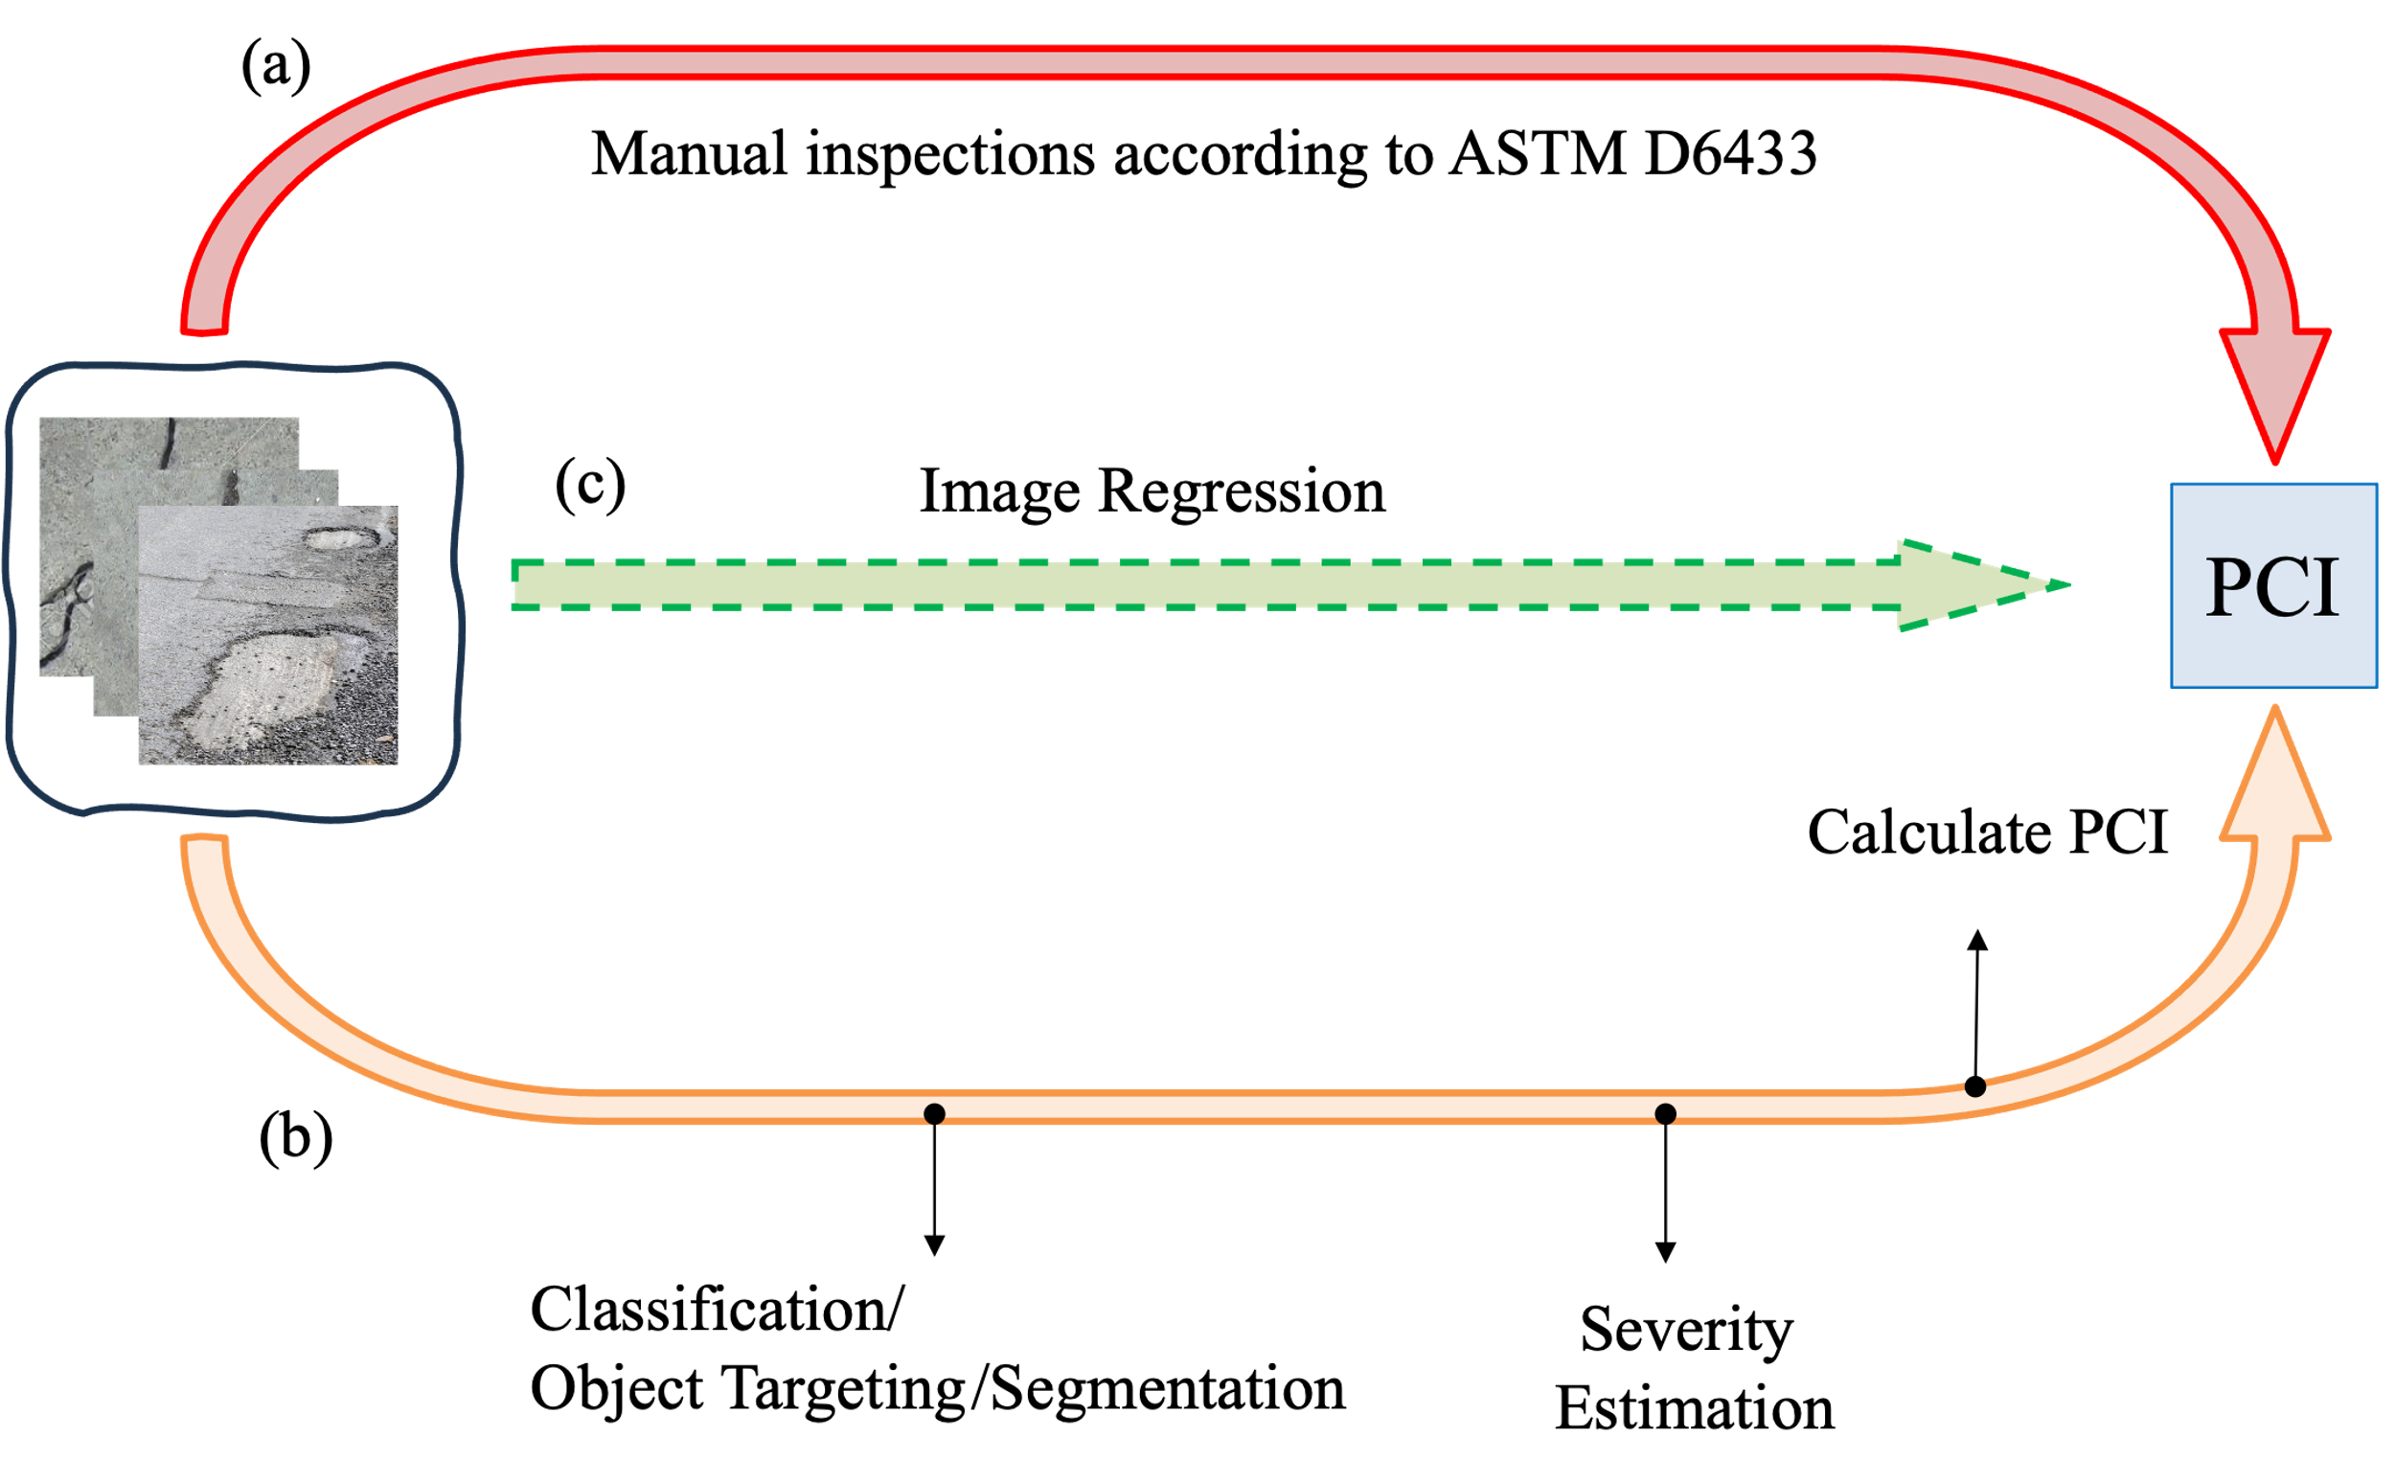
Figure 1. Ways to get PCI value from visual images: Path (a) Traditional manual inspections based on ASTM D6433-20; Path (b) Traditional automation way to calculate the PCI value from pavement section images through image classification or object targeting, defects segmentation (or instant segmentation), severity estimation and calculate PCI based on ASTM D6433-20; Path (c) The proposed image regression method.

The primary focus of the method shown in Path(b) is on collecting a substantial number of pavement images. Initially, these images undergo a classification model to categorize them into different distress types, such as cracks [13-15], rutting [16] and potholes [17]. And then, object targeting algorithms are used to target the defects in top-down view pavement images [18]. Path(b) can also use a direct instance segmentation approach that simultaneously performs object detection, classification, and segmentation [19]. Many studies were exploring and refining this step. For example, Zhang et al. [20] did a benchmark study on classic deep learning models for classifying the cracks into four types and find that ConvNeXt achieved the highest accuracy among other models. Li et al. [21] trained and compared 4 convolutional neural networks on a self-collected pavement crack dataset, reaching an overall classification accuracy of 94%. Some researchers also work on the defects targeting algorithms. For example, Wang et al. [22] proposed a vision transformer modified YOLOv5 to improve the speed and accuracy of the model targeting road cracks. In total, 1,944 asphalt images were collected by that team for testing and a mean average precision at IoU threshold 0.50 (mAP50) of 0.872 was obtained. Chen et al. [23] detected potholes successfully with a precision of 95.2% using a location-aware convolutional neural networks. There were also competitions like the Data Science for Pavement Symposium (DSPS) held by the Federal Highway Administration (FHWA) to invite students to take part into road distress targeting tasks [24]. However, these works are all limited in the distress classification or targeting, and they are mainly focused on the model performance in this step, rather than moving forward to evaluate the overall performance of a whole road or a pavement network. Without numerical predictions directly on PCI, these image-based models are merely focused on discrete features of individual distress types. They lack practical engineering indicators of present service conditions for maintenance decision-making support.
Following classification, the next step involves image segmentation, which is crucial for estimating the severity of each defect type. For instance, the segmentation process will have an impact on calculating the length of transverse cracks or determining the area affected by alligator cracks. These quantifications are essential for computing the PCI score in accordance with the ASTM D6433-20, which subsequently allows for an aggregated PCI calculation for individual road units. A lot of researchers did research on this step. For example, Zhang et al. [25] proposed an integrated APCGAN and AttuNet framework to automatically segment the cracks from the pavement background. The method was mainly focused on the small training data issue which widely exists in non-destructive detection. Fan et al. [26] introduced a graph attention layer into traditional Convolutional Neural Network (CNN) structures to optimize the image feature representation for pothole segmentation and achieved higher detection accuracy than other models.
The main problems in this method shown in Path(b) in Figure 1 to evaluate the PCI are in these facets: 1) Researchers rarely focus on the entire process, and most engineers and researchers concentrate on only one step, resulting in isolated research efforts. 2) It is computationally intensive and time-consuming to finish the whole process to calculate the PCI. 3) How to control the error and how to design the loss function to make it consistent within the PCI prediction remains a big challenge since each step would have errors.
Due to the issues faced by these two methods mentioned above, a much more convenient and computational-friendly method is needed to help road managers and engineers to evaluate the pavement much more efficiently and accurately. Therefore, a novel image regression-based approach is introduced. Unlike the common image classification or segmentation techniques, image regression enables the direct prediction of continuous values as performance indexes from images. This method has been popularly applied in other areas like estimating a person's age from their photograph [27]. However, it has not been utilized in the PCI estimation before. In 2024, the Federal Highway Administration (FHWA) organized a student competition (https://dsps-1e998.web.app/) to predict PCI values using images. The FHWA published a set of images representing pavement units, each assigned a PCI value by an expert. Therefore, in this work, an image regression neural network, PCINet, is proposed to predict the PCI value of each image from the dataset published by FHWA. By using this method, a PCI value can be directly estimated for each single image instead of doing traditional complex sequence classification, segmentation and evaluation works as described above. It can provide data-based evidence for maintenance decision-making and optimize resource allocation.
Furthermore, in most cases the pavement sections are in good condition, which is reflected in the dataset. For example, Pinatt et al. [28] found that 92.21% of roads were classified as “very good” during their survey in Maringá, Brazil. However, the pavement units in “bad” condition should be paid more attention to as it is important to road maintenance. Therefore, instead of using Mean Square Error (MSE), a customized loss function, PCILoss, is proposed for this specific application to improve the performance of the proposed model.
The organization of the paper is as follows. First, the dataset used, the proposed PCINet architecture, and the PCILoss will be introduced in Section 2. Also, the evaluation metrics as well as the overall procedure of the paper will be introduced. The PCINet would be compared with other advanced models including YOLOV8, ResNet, DenseNet and MobileNet. The results of the data preprocessing and model performance will be shown in Section 3. Finally, Section 4 provides the conclusions.

2. METHODS
2.1 Overall Procedure
Figure 2 outlines the comprehensive methodology of the study.
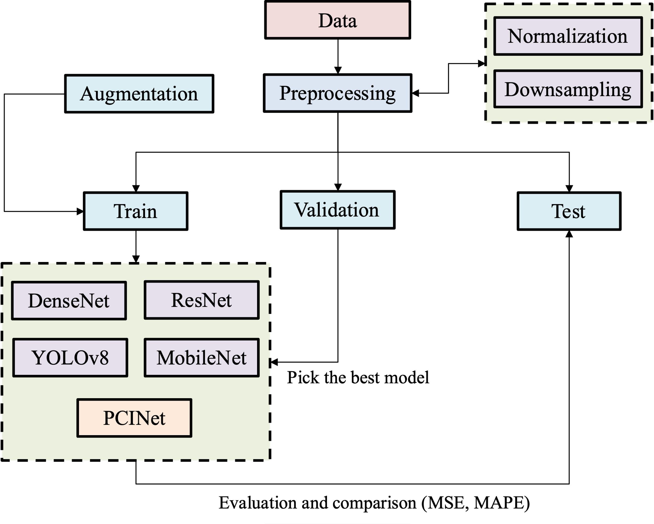
Figure 2. The overall procedure of the work.
The PCI values within our dataset displayed a non-normal, left-skewed distribution. This skewness reflects the real-world scenario where the majority of pavement surfaces are in good condition, with most images having a PCI value of 100. This imbalanced dataset presents a challenge for model training. To address the challenge of this imbalanced dataset and ensure robust model training, we implemented a downsampling strategy. Specifically, we randomly selected 10% of the images with a PCI value of 100, maintaining a proportional balance with images having different PCI values. Additionally, any extreme values are adjusted, with PCI values less than zero adjusted to zero, and all PCI values were scaled down by a factor of 100 to normalize them between 0 and 1.
Following preprocessing, the dataset was split into training, validation, and testing sets with a ratio of 8:1:1. The training set was utilized to fit the deep learning models, the validation set helped in model selection during the training process, and the test set was used to evaluate the model's performance. The images in the training dataset would be augmented based on the number of images in its category. We calculate the median number of images in all categories. If the number of images in a certain category is less than the median value, we will add some segmented images into this category.
Due to the variation in datasets, image formats, and label sources across the literature, direct comparison of absolute metric values across studies is challenging. Therefore, we emphasize the importance of benchmarking. A variety of architectures including ResNet series (ResNet18, ResNet34 and ResNet50), YOLOv8 series (YOLOv8n, YOLOv8s, YOLOv8m and YOLOv8x), DenseNet121, and MobileNet series (MobileNetv2 and MobileNetv3) are trained using this standardized dataset for comparative analysis with our proposed PCINet model.
ResNet18, ResNet34 and ResNet50 belong to residual networks [29]. These models use residual connections to mitigate the vanishing gradient problem in deep networks, enabling the training of very deep architectures with improved accuracy. The YOLOv8 (You Only Look Once version 8) series [30] are real-time object detection models that can balance speed and accuracy across scales. The series ranges from lightweight (YOLOv8n) to high-capacity (YOLOv8x), making them suitable for diverse deployment scenarios. While YOLOv8 is indeed designed for object detection, we removed the detection head and modified the final output layer into a 101-class classifier. DenseNet121 [31] employs dense connections between layers, where each layer receives the feature maps from all preceding layers. This design improves feature reuse and reduces the number of parameters while maintaining strong performance. MobileNet series (MobileNetv2 and MobileNetv3) are efficient CNN architectures optimized for mobile and edge devices. MobileNetv2 [32] uses inverted residual blocks with linear bottlenecks, while MobileNetv3 [33] integrates squeeze-and-excitation modules and neural architecture search to further optimize speed and accuracy.
For all benchmark models, the original classification heads were modified to suit the PCI prediction task. Specifically, the final fully connected layer was replaced with a 101-unit output layer corresponding to PCI values from 0 to 100, and a softmax function was applied. This allowed us to treat PCI prediction as a classification problem in the baseline models, while our proposed PCINet used direct regression. The loss function used was Categorical Cross-Entropy (CCE) [34], as shown in Equation 1.
$CCE= -\sum_{i=1}^{N}{\sum_{c=1}^{M}{y_{ic}log(p_{ic})}}$ (1)
Where N is the number of samples in the batch, M is the number of classes (M=101 in this case), $y_{ic}$ is a binary indicator (0 or 1) if class label 𝑐 is the correct classification for sample 𝑖, $p_{ic}$ is the predicted probability of sample 𝑖 being of class 𝑐.
MSE is popularly used in training regression problems like PCINet. The equation of MSE is shown below.
$MSE= \frac{1}{m}\sum_{i=1}^{m}{{(y_{i}-{\hat{y}}_{i})}^{2}}$ (2)
Where m is the data size, $y_{i}$ is the original value and ${\hat{y}}_{i}$ is the prediction result.
However, for the PCI evaluation, the most important task for engineers is to detect the low-PCI value section in pavement precisely. This is because in pavement engineering, the low-quality pavement units or pavement which has already been damaged, require engineers’ attention, since it will cause traffic security issues for both drivers and passengers. Therefore, the pavement units with low PCI should be paid more attention than the units with good condition. However, using the traditional MSE as the loss function would make the model pay attention equally to all the pavement units. It only cares about the discrepancy between the prediction one and the ground truth. Thus, a custom loss function PCILoss was proposed in this work to ease this problem. The equation of PCILoss is shown below:
$PCILoss=\frac{1}{n} \sum_{i=1}^{n}{\frac{1}{\sqrt{\left|\hat{y}\right|+1}}×{\left(y-\hat{y}\right)}^{2}}$ (3)
Where y is the original ground truth, $\hat{y}$ is the prediction result. n is the batch size, which is 32 in this case. The “+1” term is introduced to prevent division by zero since PCI values can be as low as zero in distressed pavement sections, this small offset ensures numerical stability during training. The square root of (ŷ + 1) is applied as a scaling factor to adjust the penalty distribution. Specifically, this design increases the relative penalty for errors when the predicted PCI value is small, thereby encouraging the model to focus more on low-PCI pavement units (which are more critical for maintenance decisions).
The initial learning rate is set at 0.0005, with a planned reduction by a factor of 2 (every two epochs to facilitate finer adjustments as training progresses). To mitigate the risk of an overfitting problem, an early stopping mechanism is employed, with a patience parameter of 10 epochs. It means that training would stop if there is no decrease in loss for 10 epochs. Model performance is continuously monitored using the validation set, and the model demonstrating the lowest loss on this set would be selected as the final model. This model would be subsequently evaluated on the test dataset to gather performance metrics. To account for variability from data sampling and model initialization, all experiments were repeated three times with different random seeds. The reported metrics represent the average values across runs, with error bars indicating standard deviation.

2.2 Dataset
A top-down pavement image dataset (https://github.com/UM-Titan/DSPS24) published by FHWA, the University of Missouri and the University of New Hampshire, is utilized in this work for training, validating and testing. It contains 10,000 images as well as an Excel file where the PCI value of each image is provided. Each image has a resolution of $1536×1536$ pixels. Figure 3(a) provides some visualization of images in the dataset with different PCI values. The dataset contains different types of cracks including longitudinal cracks, transverse cracks and alligator cracks, as well as pothole, raveling, rutting, patches and so on. Figure 3(b) shows the distribution of PCI values in the original dataset.
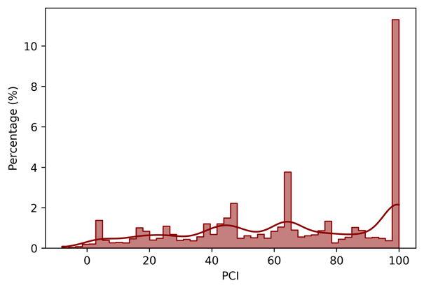
(a) (b)
Figure 3. (a) Visualization of images in the dataset with different PCI values; (b) The distribution of PCI in the original dataset;

As illustrated in Figure 3(b), the PCI distribution is heavily left-skewed, with the number of images having a PCI value of 100 significantly higher than any other values. This is acceptable since, in real-life situations, the percentage of pavement in good condition is generally higher than that of pavements in poor condition [35]. However, such skewed data is not suitable for deep learning model training as it can cause the model to overweight images with high PCI values.
A preprocessing procedure, including correcting invalid PCI values, data downsampling, and augmenting underrepresented classes is employed to address this skewed issue. The images with a PCI of 100 are downsampled by randomly deleting a certain percentage of these images. Additionally, images with lower quantities are upsampled using image augmentation strategies such as rotating, and flipping. The median number of images is calculated across all PCI values, and if the number of images for a particular PCI is below the median, this set will be augmented by adding the generated images.
During training, the deep learning model updates its parameters iteratively. The validation set helps in selecting the best model, while the test set is used to calculate the final metrics. Before feeding the images into the models, the original images are resized to 640$×$640 pixels and normalized. This resizing ensures a uniform input size, which is crucial for consistent performance and computational efficiency in the neural network. Normalization adjusts the pixel values to a standard range, improving the convergence rate during training. The PCI values, originally between 0 and 100, are converted to a scale from 0 to 1 by dividing each value by 100. This scaling helps in stabilizing the training process and ensuring that the model treats the PCI values in a consistent and proportional manner.

2.3 PCINet
The proposed Pavement Condition Index Neural Network (PCINet) introduces an innovative architecture aimed at enhancing the analysis and interpretation of pavement conditions. Unlike traditional CNNs, which are primarily tailored for classification or segmentation tasks, PCINet is meticulously designed to address specific challenges in pavement condition evaluation through deep learning using image regression. The architecture of PCINet is depicted in Figure 4.
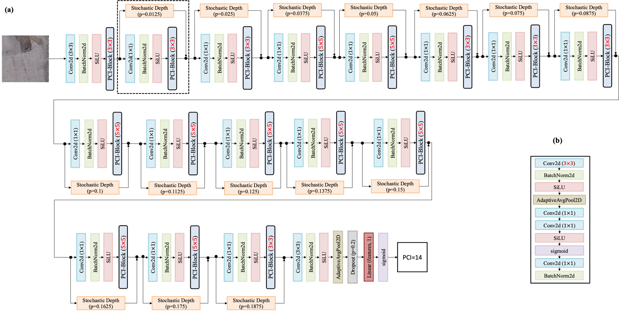
Figure 4. (a) Model architecture of the proposed PCINet. The value p means the possibility of skipping this layer. SiLU stands for Sigmoid Linear Unit activate function. Conv2d represents the convolutional layer and BatchNorm stands for batch normalization layer. (b) Structure of the PCI-Block which contains 4 convolutional layers in each block.

Figure 4(a) is the main structure of PCINet. It is composed of 81 convolutional layers (Conv2d), which facilitate a deeper and more detailed feature extraction compared to shallower networks. Deep neural networks are pivotal in capturing nuanced patterns in data. In the PCI-Block design, both 3×3 and 5×5 convolution kernels are employed to balance local detail extraction and broader contextual understanding. The 3×3 kernels serve as the default choice due to their efficiency in capturing fine-grained features such as small cracks and localized pavement irregularities, while maintaining a relatively low parameter count. In contrast, the 5×5 kernels are selectively applied in deeper layers to expand the receptive field and capture more global structural patterns, such as the spread of alligator cracking or the extent of pothole areas. Structurally, both kernel types follow the same convolution–batch normalization–activation sequence, differing only in their kernel size. This hybrid configuration allows PCINet to learn complementary information at different spatial scales, improving its robustness across diverse distress types without introducing excessive computational complexity.
However, they often encounter challenges such as vanishing gradients [29] during backward propagation and diminished feature reuse in forward propagation. To mitigate these issues, PCINet incorporates a technique known as Stochastic Depth [36]. This method probabilistically skips certain layers during training, effectively reducing the network's operational depth and thus alleviating the vanishing gradient problem without compromising learning capability. For instance, as depicted in the dotted rectangular box in Figure 4(a), the parameter p=0.0125 signifies a 1.25% chance of skipping specific layers, thereby simplifying the model complexity adaptively during training phases. A larger p means a larger chance to skip the associated layers.
Each convolutional layer is followed by a Batch Normalization (BatchNorm2d) layer, which standardizes the outputs of the previous layer by adjusting and scaling activations. This normalization is described by Equation 4 below [37].
$y=\frac{x-μ}{\sqrt{σ^{2}+ϵ}}×γ+β$ (4)
Where $μ$ is the mean value per-dimension over the mini-batches while $σ^{2}$ is the variance. The parameters 𝛾 and 𝛽 are learnable parameters that are adapted during training. The initialization of 𝛾 to 1 and 𝛽 to 0 allows the network to initially behave like an identity function, not altering the input, and gradually learning the optimal normalization.
The activation function employed in PCINet is the Sigmoid Linear Unit (SiLU) function [34], as shown in Equation 5.
$SiLU(x)=x×σ(x)$ (5)
where $σ(∙)$ is the logistic sigmoid function. $SiLU(∙)$ provides non-linear capabilities essential for deep learning models, allowing them to capture complex relationships in the data. This choice of activation function is instrumental in enhancing non-linearity without introducing additional parameters or computational complexity.
At the end of the convolutional layers within PCINet, a fully connected (Linear) layer is incorporated to synthesize the deeply processed features into a singular output value. This layer plays a crucial role in the network's architecture by aggregating the spatially distributed feature maps into a compact form. The output of this fully-connected layer is a continuous value that represents the predicted PCI, thereby transforming the rich, complex feature representations extracted by the preceding convolutional layers into a precise quantitative assessment of pavement condition.
Subsequent to the fully connected layer, a sigmoid activation function is strategically employed at the output stage of PCINet, as shown in Equation 6.
$σ\left(x\right)=\frac{1}{1+e^{-x}}$ (6)
Given that the PCI values are scaled between 0 and 1, the sigmoid function is ideal as it confines the output of the network within this range. The sigmoid function ensures that the network’s output, the predicted PCI, remains within the realistic bounds of 0 to 1. This feature is critical for maintaining the integrity and usability of the PCI estimates produced by the network, making them directly applicable for evaluating pavement conditions. Since the ground-truth PCI values are scaled to the [0, 1] range during preprocessing, the sigmoid output can be directly compared to the normalized labels during training. In inference, the predicted value is multiplied by 100 to map it back to the original PCI scale (0–100). This design ensures that the model functions as a regression network while enforcing realistic bounds on the predictions.
By implementing the sigmoid function, PCINet ensures that the regression output adheres to the expected limits of PCI values, thereby enhancing the reliability and interpretability of the predictions. This decision underlines the tailored design of the network, specifically optimized for the regression task at hand, demonstrating the model’s capability to deliver actionable and precise pavement condition assessments directly from input images.

2.4 Evaluation Metrics
In the regression problem, the MSE and Mean Absolute Error (MAE) are the most commonly used metrics to evaluate the performance of the model. In our case, more attention needs to be paid to the low-PCI pavement units. Compared to MSE and MAE, Mean Absolute Percentage Error (MAPE) will help the model pay more attention to the lower-PCI images as it calculates error as a percentage of the actual value. The equation of MAPE is shown below.
$MAPE= \frac{1}{n}\sum_{i=1}^{n}{{(\frac{y_{i}-{\hat{y}}_{i}}{y_{i}})}^{2}}$ (7)
Where n is the size of data, $y_{i}$ is the original value and ${\hat{y}}_{i}$ is the prediction result. MSE and MAE can help us learn the overall performance of the model while MAPE would help us understand the performance of the model on the small-PCI pavement sections.
A PCI error which is calculated based on MSE, MAE and MAPE is also proposed in this work. The equation of PCI error is shown below.
$PCI error= \frac{1}{3k}\sum_{i=1}^{k}{\left\{\frac{{\left(y_{i}-{\hat{y}}_{i}\right)}^{2}-μ_{MSE}}{σ_{MSE}}+\frac{\left|y_{i}-{\hat{y}}_{i}\right|-μ_{MAE}}{σ_{MAE}}+\frac{{\left(\frac{y_{i}-{\hat{y}}_{i}}{y_{i}}\right)}^{2}-μ_{MAPE}}{σ_{MAPE}}\right\}}$ (8)
Where k is the size of the test data. MSE captures the square of errors, heavily penalizing larger errors. MAE considers the absolute value of errors, providing a linear penalty for errors. MAPE pays more attention to the small value. Directly combining MSE, MAE, and MAPE without any adjustments can introduce bias due to their different scales assessment. Thus, each term of error is standardized by min-max scaling, maintaining the proportional relationships of errors in a bounded [0,1] range. By incorporating all three metrics, the PCI error offers a more balanced and holistic view of the model's performance across different aspects of error measurement. Also, it allows for better robustness and reduced sensitivity to outliers compared to using a single metric.

3. RESULTS
In this part, the results of our data preprocessing method are presented. Also, the performance of PCINet is evaluated based on the test dataset and is compared with other advanced models including the YOLOv8 series, ResNet series, MobileNet series and DenseNet121.

3.1 Data Preprocessing
Figure 5 illustrates the distribution of the PCI across the dataset. The dark red histogram represents the original dataset, while the dark blue histogram indicates the data after preprocessing.
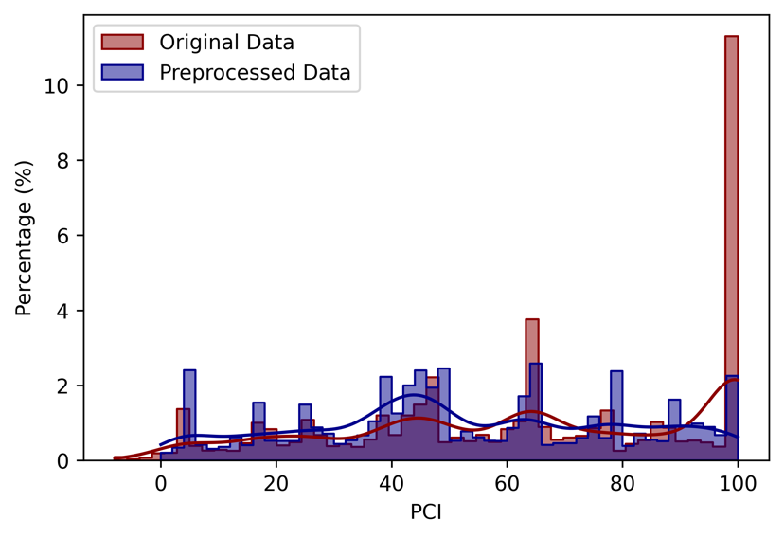
Figure 5. The distribution of the PCI in the dataset. The dark red histogram represents the original dataset. The dark blue histogram stands for the data after processing.
As depicted in Figure 5, the original dataset is unbalanced. There are over 10% of the images labeled with a PCI value of 100. Additionally, there were some anomalous values where images were assigned a PCI value below 0, which is not feasible given that the PCI standard specifies a range from 0 to 100. These values likely resulted from data entry or labeling errors.
To address these issues, several data preprocessing steps were employed. First, images with a PCI value less than 0 were identified as representing severely damaged pavement sections and were adjusted to a PCI value of 0. A downsampling strategy was applied to images with a PCI of 100, reducing their proportion to approximately 2% of the dataset, which created a more balanced and reasonable distribution. This reduction is evident from the adjusted histogram in Figure 5, ensuring the model does not disproportionately focus on high PCI value pavement units, which could skew its overall performance.
Furthermore, augmentation techniques such as flipping were applied to minority PCI categories to enhance data diversity. The decision on which PCI categories to augment was based on a median calculation of image counts across all categories. Categories with image counts below this median were selected for augmentation, optimizing the representation across the dataset. The final data distribution after data preprocessing is shown in Figure 5.
The comparison between PCINet performance on the processed dataset and the original dataset is conducted. The results are shown in Figure 6. The error bars in Figure 6 represent the standard deviation of performance metrics calculated over three repeated runs with different random seeds. Each run involved reinitializing the model and retraining it on the same dataset split. This provides a measure of variability and robustness in the model’s performance.
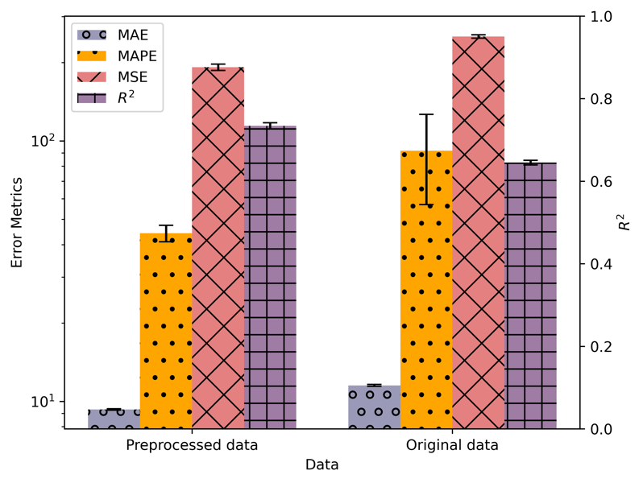
Figure 6. The PCINet performance comparison of original data and preprocessed data
By comparing the PCINet which is trained on preprocessed data and the original dataset, it shows that after the data processing, it can better improve the performance of the model by removing some imbalanced data and some extreme data. We can conclude that the balanced data can help the model gain a higher coefficient of determination ($R^{2}$) value of 0.734 compared to 0.645 when using the original dataset. Additionally, the MAE decreased from 11.52 to 9.32, and the MAPE was reduced from 91.72 to 44.23. A Welch’s t-test was conducted to assess statistical significance. The differences in R² (p = 0.0081), MAE (p = 6.56×10⁻⁵), and MSE (p = 0.0104) between the PCILoss model and the original-data model were found to be statistically significant at the 95% confidence level (p < 0.05), while the difference in MAPE (p = 0.1395) was not statistically significant.
These results affirm that a balanced dataset, free from extreme and imbalanced values, significantly enhances model efficacy. This preprocessing approach not only improved the accuracy of the PCINet but also demonstrated the importance of dataset integrity in developing reliable and robust predictive models.

3.2 Model Performance Comparison
Figure 7 presents a comparative analysis between using MSE as the loss function for PCINet and our proposed loss function, to evaluate whether the PCILoss enhances the model's performance. Error bars represent the standard deviation calculated over multiple independent training runs. Specifically, each model was trained 3 times using different random seeds to capture variation in performance.
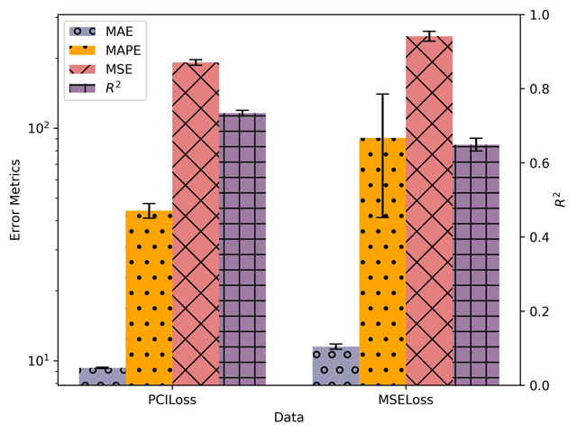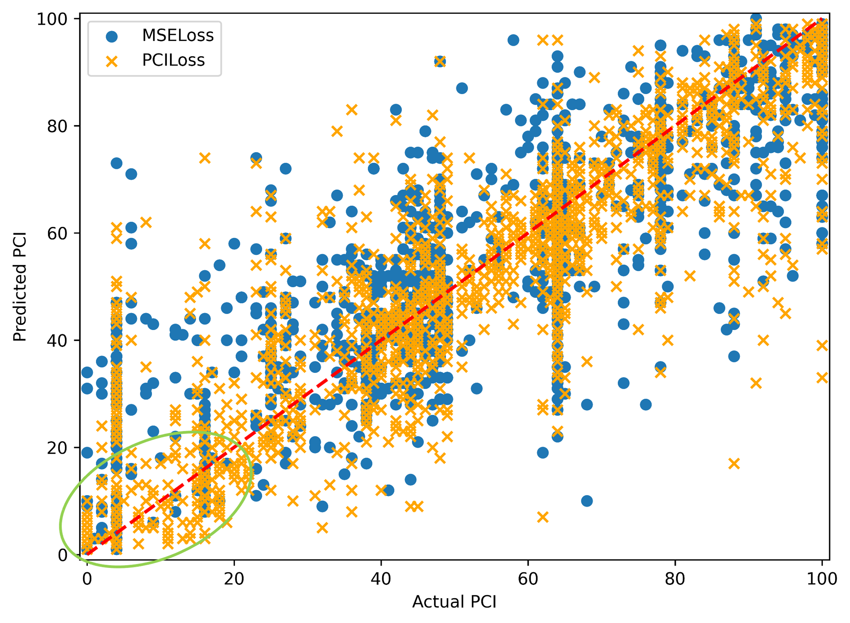
(a) (b)
Figure 7. The performance comparison of PCINet when using PCILoss and MSELoss (a) The error metrics and $R^{2}$ value when using different loss functions in training; (b) The comparison of the actual PCI value and its predicted PCI value. The red dash line is y=x.
The comparison in Figure 7(a) illustrates an improvement in evaluation metrics when employing our proposed PCILoss. The model achieves a higher $R^{2}$ value of 0.734 with PCILoss, compared to 0.649 using MSELoss. This enhancement in $R^{2}$ indicates a better fit of the model to the data. Furthermore, MAE, MAPE and MSE show substantial reductions, with MAE decreasing from 11.50 to 9.32, MAPE from 90.78 to 44.23 and MSE from 248.7 to 191.9.
To determine whether the observed performance improvements are statistically significant, we applied Welch’s t-tests on key evaluation metrics (MSE, MAE, MAPE, and R²). The results indicate that the improvements in MSE (p = 0.0066), MAE (p = 0.0045), and R² (p = 0.0058) are statistically significant at the 95% confidence level, while the improvement in MAPE (p = 0.2446) is not statistically significant. These findings suggest that the PCILoss not only improves the average performance but does so in a statistically meaningful way, especially in reducing absolute and squared errors and improving overall model fit (R²).
Figure 7(b) is a comparison between the actual PCI value and its predicted PCI value. The R² value of the PCILoss and MSELoss is 0.734 and 0.649, respectively. The red dashed line represents the identity line (y=x), where perfect predictions would lie. The proximity of the data points to this line indicates the accuracy of the model predictions. Points closer to the line reflect more accurate predictions. It is notable that in the low PCI part as shown in the green circle in Figure 7(b), the prediction result with PCILoss is apparently better than the model trained by MSELoss. This demonstrates that our proposed loss function not only enhances the model's overall performance but also its precision in predicting lower PCI values although the improvement in MAPE is not significant. It is crucial for identifying more severely damaged pavement sections.
PCINet is also evaluated and compared with other advanced models such as DenseNet, MobileNet series, ResNet series, and YOLOv8 series across various metrics including MSE, MAE, MAPE, and $R^{2}$ as displayed in Figure 8 (a) through (d). To ensure the results are reliable, each model was trained and evaluated across three independent runs. The reported values in Figure 8 are the means of these runs, and the error bars represent standard deviations.
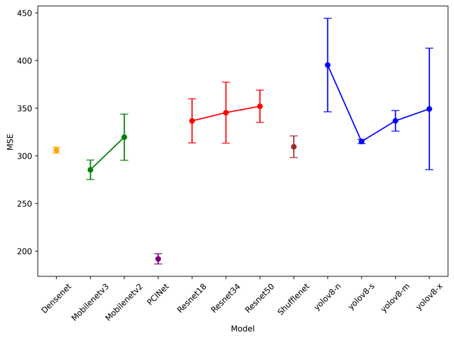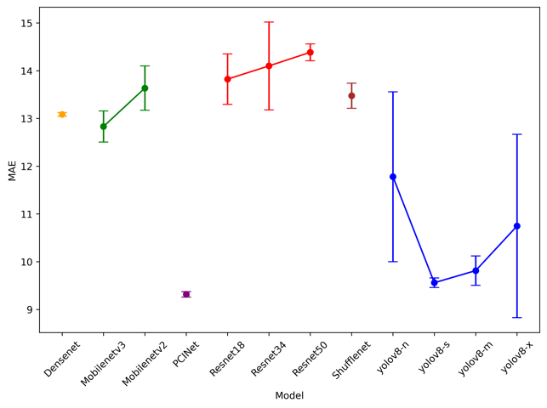
(a) (b)
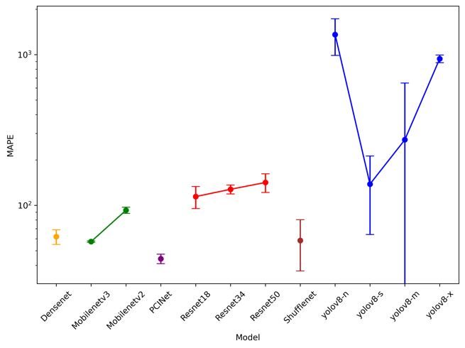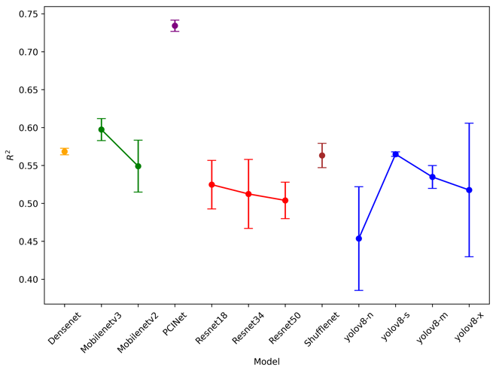
(c) (d)
Figure 8. Performance comparison of PCINet and other baseline models across four metrics: (a) MSE; (b) MAE; (c) MAPE; (d) $R^{2}$.

Figure 8 (a)-(d) illustrate the error metrics and $R^{2}$respectively for each model under test conditions. The purpose of using lines within each model group (e.g., YOLOv8 series or ResNet series) is to visually group and compare related architectures. Our proposed PCINet model shows a superior performance, achieving the lowest error metrics, MSE at 191.9, MAE at 9.32, and MAPE at 44.23, and the highest $R^{2}$of 0.734. These figures signify a robust model that maintains high precision and accuracy, particularly in contexts where precise PCI evaluation is crucial.
Intriguingly, the YOLOv8 series models exhibit higher variance in their performance as indicated by the error bars across all metrics. This suggests a potential overfitting issue or a sensitivity to the specific characteristics of the test data, which might compromise their reliability in practical applications. It is interesting to find that when we add more layers to the model, all types of errors increase. This could be because the model becomes too complex for the amount of data we have to train it. This is a common problem with very deep networks, where adding more layers doesn’t always make the model better and can sometimes even make performance worse.
Conversely, the MobileNet series shows better error statistics compared to ResNet, which may be due to its more efficient handling of parameters and lighter network architecture designed specifically for mobile and embedded vision applications. This efficiency could translate to better generalization on the test dataset.
This comprehensive evaluation underscores the efficacy of PCINet, particularly its ability to handle the nuances of pavement condition assessment more adeptly than the other models considered. The lower error metrics and higher $R^{2}$ value achieved by PCINet highlight its superior predictive power and model fit, making it an exceptional tool for infrastructure assessment tasks.
This superior performance can also be attributed to the specialized design of our PCILoss, which strategically emphasizes learning on critical lower PCI values. This focus contrasts with CCELoss typically employed in classification models, where the error is not contingent upon the magnitude of the PCI value but solely on the accuracy of the class prediction. For instance, consider a scenario where the true class of an image is PCI=1. If the model incorrectly predicts PCI=2 or PCI=100, CCELoss would impose the same penalty on both predictions, despite the vast difference in error magnitude. Conversely, our tailored PCILoss introduces a more nuanced approach, assigning a lesser penalty for the prediction of PCI=2 than for PCI=100, reflecting a more proportional and contextually sensitive error evaluation. This targeted penalty system ensures that our model is not only accurate but also precise, especially in its treatment of near-miss predictions that are close in value to the true class.
Figure 9 illustrates the comparative performance of various models in terms of PCI error, a novel metric introduced in this study. The PCI error is computed based on MSE, MAE, and MAPE, providing a balanced assessment of model accuracy.
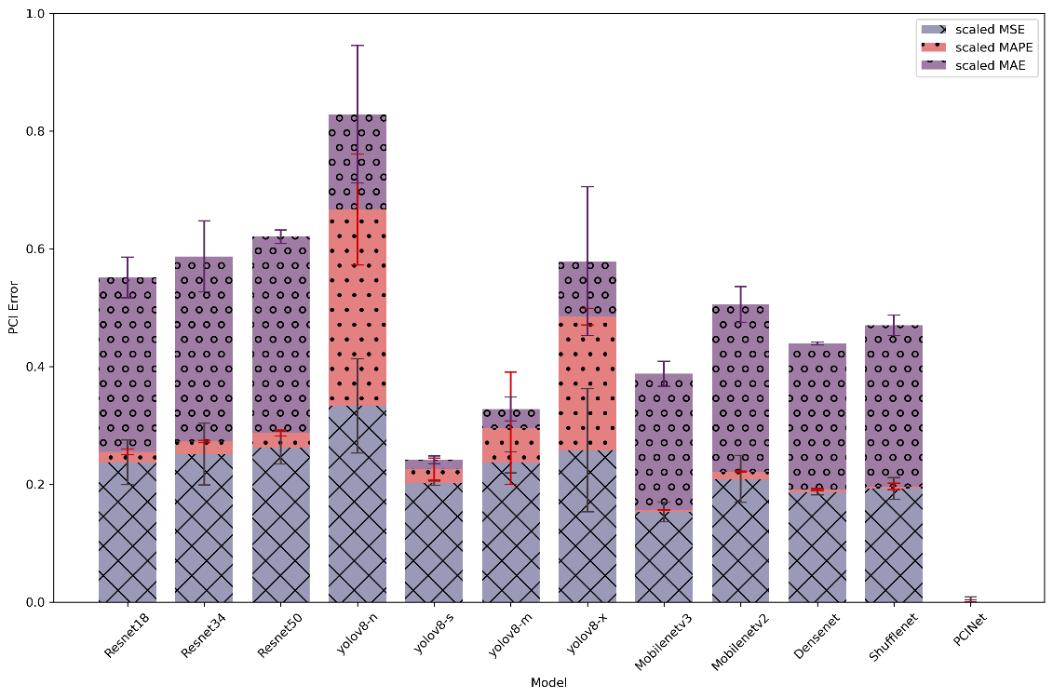
Figure 9. The PCI error of different models.
As observed in Figure 9, the YOLOv8n model registers the highest average PCI error at 0.83, followed by ResNet50 and YOLOv8x with a PCI error of 0.62 and 0.58. The primary factor contributing to the elevated PCI error in these YOLOv8n and YOLOv8x models is their poor performance on MAPE, despite similar or even smaller MSE and MAE across all models. This indicates that while the overall performance on predicting PCI values is relatively uniform, YOLOv8n and YOLOv8x models exhibit significant deficiencies in accurately predicting lower PCI values.
It is evident that the proposed PCINet model exhibits significantly lower PCI error (0), which means PCINet obtains the lowest MSE, MAE and MAPE among all the models. It indicates its superior ability to balance its performance in terms of MSE, MAE, and MAPE. The error bars, representing the variability within the test data, further emphasize the robustness of PCINet in maintaining consistent performance across different data samples.
The superior performance of PCINet compared to other deep learning models can be attributed to a combination of architectural, methodological, and training innovations. First, our use of a regression-based approach enables direct prediction of continuous PCI values, avoiding the quantization error inherent in classification-based models that treat PCI as 101 discrete classes. This aligns more closely with the continuous nature of the PCI scale and allows the model to better capture subtle variations in pavement condition. Additionally, PCINet is specifically designed for the PCI prediction task, with a deep architecture consisting of 81 convolutional layers and the integration of stochastic depth. This allows the model to maintain high representational capacity while avoiding vanishing gradients and overfitting issues that often arise in deep networks when applied to noisy, imbalanced datasets. Another key factor is our carefully balanced training data. By downsampling overrepresented PCI = 100 samples and augmenting underrepresented PCI categories, we ensure the model receives diverse and balanced examples across the PCI spectrum, especially improving performance on low-PCI segments. Finally, the use of a custom loss function, PCILoss, which places greater emphasis on accurately predicting lower PCI values, further improves the model’s practical relevance for identifying deteriorated pavement. Together, these choices lead to statistically significant improvements in R², MSE, and MAE over all baseline models, as confirmed by Welch’s t-tests (p < 0.05).
4. DISCUSSION
Although PCINet demonstrates promising performance on the DSPS24 dataset, several limitations remain regarding data acquisition and model generalization. The dataset was collected using infrastructure-mounted cameras in the Washington, D.C. area, but detailed acquisition metadata such as mounting height, camera type, shooting angle, acquisition speed, and illumination conditions were not provided. These factors directly influence the visual characteristics of pavement images and may affect the reproducibility of results when applying PCINet to other datasets or in real-world scenarios.
Variations in acquisition conditions, including differences in resolution, illumination, shooting distance, and viewing angle, can significantly impact the appearance of pavement distresses. For example, shadows, low-light environments, or oblique viewing angles may obscure cracks or alter their visual representation, potentially reducing the accuracy of PCI predictions. While PCINet is not tied to a single acquisition setup, retraining or fine-tuning would be necessary to ensure robust performance across diverse imaging conditions. Data augmentation strategies, such as random brightness adjustments, geometric transformations, and noise injection, can also be applied to improve model resilience against these variations.
Furthermore, the lack of publicly available datasets with paired PCI labels limits opportunities for broader benchmarking and reproducibility studies. Expanding the dataset to include images captured under different weather conditions, pavement types, and geographic regions would allow for more comprehensive validation of PCINet. Future research will therefore focus on collecting heterogeneous datasets and exploring transfer learning approaches to enhance model adaptability and generalization across diverse acquisition environments.

5. CONCLUSIONS
In this study, a novel neural network architecture designed for the accurate prediction of the Pavement Condition Index (PCI) using top-down view pavement imagery is introduced. This image regression technology distinguishes itself by its ability to directly predict continuous PCI values. It addresses the limitations inherent in traditional manual assessments and image-based methods. In the proposed PCINet, we use very deep convolutional layers but incorporate stochastic depth to avoid vanishing gradients during backward propagation during training. Data preprocessing is utilized for skewed data, including correcting invalid PCI values, downsampling and image augmentation, to make the dataset more balanced to train the model.
A customized loss function, PCILoss, is proposed to help the model train better. PCILoss considers the importance of small PCI values and adds heavier weight to the residual from smaller PCI values. This adjustment significantly boosts the model's performance by focusing on the critical aspects of pavement deterioration that require more immediate attention.
Moreover, we proposed a novel metric, PCI error, to quantitatively assess and evaluate the model performance. It aggregates MSE, MAE, and MAPE to provide a holistic measure of accuracy. In order to show the advance of our proposed method, some other advanced models including the ResNet series (ResNet18, ResNet34 and ResNet50), YOLOv8 series (YOLOv8n, YOLOv8s, YOLOv8m and YOLOv8x), DenseNet121, and MobileNet series (MobileNetv2 and MobileNetv3) were also trained and evaluated on the same dataset. The results show that PCINet outperforms conventional models, achieving the highest $R^{2}$ of 0.734 and the lowest PCI error.
Despite these advancements, there are some limitations we need to improve. For example, the images in the dataset are only collected from three cities and all the top-down view images are taken in good weather conditions. It might limit the generalizability of our findings. To enhance the robustness and applicability of PCINet, future research will aim to expand the dataset with a more heterogeneous collection of images, encompassing diverse geographical locations and varying environmental conditions.

AUTHOR CONTRIBUTIONS
The authors confirm contribution to the paper as follows: study conception and design: T. Zhang, and Y. Lu; data collection: T. Zhang; analysis and interpretation of results: T. Zhang, H. Wang; draft manuscript preparation: T. Zhang, H. Wang, and Y. Lu. All authors reviewed the results and approved the final version of the manuscript.

Declaration of Generative AI and AI-Assisted Technologies in the Writing Process

During the preparation of this work, the author(s) used ChatGPT (OpenAI) in order to assist with language polishing, paraphrasing, and improving clarity in technical writing. After using this tool, the author(s) reviewed and edited the content as needed and take(s) full responsibility for the content of the publication.

REFERENCES
[1] Z. Liu, W. Wu, X. Gu, S. Li, L. Wang, T. Zhang, Application of combining YOLO models and 3D GPR images in road detection and maintenance, Remote Sensing 13(6) (2021) 1081.
[2] A.A. Elhadidy, S.M. El-Badawy, E.E. Elbeltagi, A simplified pavement condition index regression model for pavement evaluation, International Journal of Pavement Engineering 22(5) (2021) 643-652.
[3] A. Sidess, A. Ravina, E. Oged, A model for predicting the deterioration of the pavement condition index, International Journal of Pavement Engineering 22(13) (2021) 1625-1636.
[4] A.A. Ali, A. Milad, A. Hussein, N.I.M. Yusoff, U. Heneash, Predicting pavement condition index based on the utilization of machine learning techniques: A case study, Journal of Road Engineering 3(3) (2023) 266-278.
[5] S.A. Arhin, L.N. Williams, A. Ribbiso, M.F. Anderson, Predicting pavement condition index using international roughness index in a dense urban area, Journal of Civil Engineering Research 5(1) (2015) 10-17.
[6] A. Standard, D6433: Standard Practice for Roads and Parking Lots Pavement Condition Index Surveys, Annual Book of ASTM Standards, ASTM International, West Conshohocken, PA (2013).
[7] E. Ibrahim, S. El-Badawy, M. Ibrahim, E. Elbeltagi, A modified pavement condition rating index for flexible pavement evaluation in Egypt, Innovative Infrastructure Solutions 5 (2020) 1-17.
[8] K. Wu, Development of PCI-based pavement performance model for management of road infrastructure system, Arizona State University2015.
[9] T. Zhang, D. Wang, Y. Lu, RheologyNet: A physics-informed neural network solution to evaluate the thixotropic properties of cementitious materials, Cement and Concrete Research 168 (2023) 107157.
[10] T. Zhang, A. Smith, H. Zhai, Y. Lu, LSTM+ MA: A Time-Series Model for Predicting Pavement IRI, Infrastructures 10(1) (2025) 10.
[11] T. Zhang, D. Wang, Y. Lu, A Navier–Stokes-Informed Neural Network for Simulating the Flow Behavior of Flowable Cement Paste in 3D Concrete Printing, Buildings 15(2) (2025) 275.
[12] T. Zhang, 3d Concrete Printing Material Prediction and Flow Simulation Using Physics-Informed Neural Network, Boise State University, 2024.
[13] T. Zhang, D. Wang, Y. Lu, ECSNet: An Accelerated Real-Time Image Segmentation CNN Architecture for Pavement Crack Detection, IEEE Transactions on Intelligent Transportation Systems (2023).
[14] S. Li, X. Gu, X. Xu, D. Xu, T. Zhang, Z. Liu, Q. Dong, Detection of concealed cracks from ground penetrating radar images based on deep learning algorithm, Construction and Building Materials 273 (2021) 121949.
[15] J. Jing, X. Yang, L. Ding, H. Wang, J. Guan, Y. Hou, S.M. El-Badawy, Self-adaptive 2D3D image fusion for automated pixel-level pavement crack detection, Automation in Construction 168 (2024) 105756.
[16] M.-T. Cao, K.-T. Chang, N.-M. Nguyen, V.-D. Tran, X.-L. Tran, N.-D. Hoang, Image processing-based automatic detection of asphalt pavement rutting using a novel metaheuristic optimized machine learning approach, Soft Computing 25(20) (2021) 12839-12855.
[17] M.H. Yousaf, K. Azhar, F. Murtaza, F. Hussain, Visual analysis of asphalt pavement for detection and localization of potholes, Advanced Engineering Informatics 38 (2018) 527-537.
[18] T. Zhang, D. Wang, Y. Lu, A data-centric strategy to improve performance of automatic pavement defects detection, Automation in Construction 160 (2024) 105334.
[19] J. Zhou, Y. Wang, W. Zhou, Efficient instance segmentation framework for UAV-based pavement distress detection, Automation in Construction 175 (2025) 106195.
[20] T. Zhang, D. Wang, Y. Lu, Benchmark Study on a Novel Online Dataset for Standard Evaluation of Deep Learning-based Pavement Cracks Classification Models, KSCE Journal of Civil Engineering (2024) 1-13.
[21] B. Li, K.C. Wang, A. Zhang, E. Yang, G. Wang, Automatic classification of pavement crack using deep convolutional neural network, International Journal of Pavement Engineering 21(4) (2020) 457-463.
[22] S. Wang, X. Chen, Q. Dong, Detection of asphalt pavement cracks based on vision transformer improved YOLO V5, Journal of Transportation Engineering, Part B: Pavements 149(2) (2023) 04023004.
[23] H. Chen, M. Yao, Q. Gu, Pothole detection using location-aware convolutional neural networks, International Journal of Machine Learning and Cybernetics 11(4) (2020) 899-911.
[24] A. Behzadian, T.W. Muturi, T. Zhang, H. Kim, A. Mullins, Y. Lu, N.J. Owor, Y. Adu-Gyamfi, W. Buttlar, M. Hamed, The 1st Data Science for Pavements Challenge, arXiv preprint arXiv:2206.04874 (2022).
[25] T. Zhang, D. Wang, A. Mullins, Y. Lu, Integrated APC-GAN and AttuNet Framework for Automated Pavement Crack Pixel-Level Segmentation: A New Solution to Small Training Datasets, IEEE Transactions on Intelligent Transportation Systems (2023).
[26] R. Fan, H. Wang, Y. Wang, M. Liu, I. Pitas, Graph attention layer evolves semantic segmentation for road pothole detection: A benchmark and algorithms, IEEE transactions on image processing 30 (2021) 8144-8154.
[27] V. Sheoran, S. Joshi, T.R. Bhayani, Age and gender prediction using deep cnns and transfer learning, Computer Vision and Image Processing: 5th International Conference, CVIP 2020, Prayagraj, India, December 4-6, 2020, Revised Selected Papers, Part II 5, Springer, 2021, pp. 293-304.
[28] J.M. Pinatt, M.L. Chicati, J.S. Ildefonso, C.R.G.D.a. Filetti, Evaluation of pavement condition index by different methods: Case study of Maringá, Brazil, Transportation Research Interdisciplinary Perspectives 4 (2020) 100100.
[29] K. He, X. Zhang, S. Ren, J. Sun, Deep residual learning for image recognition, Proceedings of the IEEE conference on computer vision and pattern recognition, 2016, pp. 770-778.
[30] R. Varghese, M. Sambath, Yolov8: A novel object detection algorithm with enhanced performance and robustness, 2024 International Conference on Advances in Data Engineering and Intelligent Computing Systems (ADICS), IEEE, 2024, pp. 1-6.
[31] G. Huang, Z. Liu, L. Van Der Maaten, K.Q. Weinberger, Densely connected convolutional networks, Proceedings of the IEEE conference on computer vision and pattern recognition, 2017, pp. 4700-4708.
[32] M. Sandler, A. Howard, M. Zhu, A. Zhmoginov, L.-C. Chen, Mobilenetv2: Inverted residuals and linear bottlenecks, Proceedings of the IEEE conference on computer vision and pattern recognition, 2018, pp. 4510-4520.
[33] A. Howard, M. Sandler, G. Chu, L.-C. Chen, B. Chen, M. Tan, W. Wang, Y. Zhu, R. Pang, V. Vasudevan, Searching for mobilenetv3, Proceedings of the IEEE/CVF international conference on computer vision, 2019, pp. 1314-1324.
[34] S. Elfwing, E. Uchibe, K. Doya, Sigmoid-weighted linear units for neural network function approximation in reinforcement learning, Neural networks 107 (2018) 3-11.
[35] A. ODERA, M. HENRY, A. Azam, Characterization of missingness and data-driven imputation for incomplete pavement condition data, Intelligence, Informatics and Infrastructure 5(1) (2024) 57-71.
[36] G. Huang, Y. Sun, Z. Liu, D. Sedra, K.Q. Weinberger, Deep networks with stochastic depth, Computer Vision–ECCV 2016: 14th European Conference, Amsterdam, The Netherlands, October 11–14, 2016, Proceedings, Part IV 14, Springer, 2016, pp. 646-661.
[37] S. Ioffe, C. Szegedy, Batch normalization: Accelerating deep network training by reducing internal covariate shift, International conference on machine learning, pmlr, 2015, pp. 448-456.

